**­Level 4/5 Group 14 – week 6 –**

**Date and time of meeting/ duration**

* 07/03/2018 –

**Who attended?**

* Ethan Ward
* Mircea Lazar
* Petrut Vasile
* Toby White – not present, let us know via email.

**Topic**

* Talked about the email exchange between Mircea and Toby
* Talked about tasks that will be set for this weeks sprint
* Why some f the tasks were not completed

**Notes/Ideas from this meeting**

No work that I can find for two of Toby’s tasks on Jira, even though they are set to “In Progress”.

He is not in today so I will have to talk to him about it on the Friday meeting.

This week there was some disagreements within the group mainly between Mircea and Toby. I have included screen shots of the emails down below so the conversation can be seen.

The background task that Mircea was referring to in the email was one given to Toby in an earlier week on Jira and was moved to completed. When asked in the meeting for that sprint where it was (as it was not on GitHub) Toby said that it was done and that he would upload it later.

Proposed solution to the problem:

Toby and Mircea decide on a day to go through their tasks and the art work to get a better idea of their work style and make sure that there is no overlap on the art assets again.

Additionally Ethan will make sure that toby is moving items in Jira and uploading to GitHub.

**Meetings before / on Wednesday?**

Friday 9th at 11 to talk about the design of the game (Ethan, Mircea and Toby)

Monday 12th at 12 to make sure everyone is ok with their tasks

Wednesday 14th at 11 with Rob for meeting with lecturer

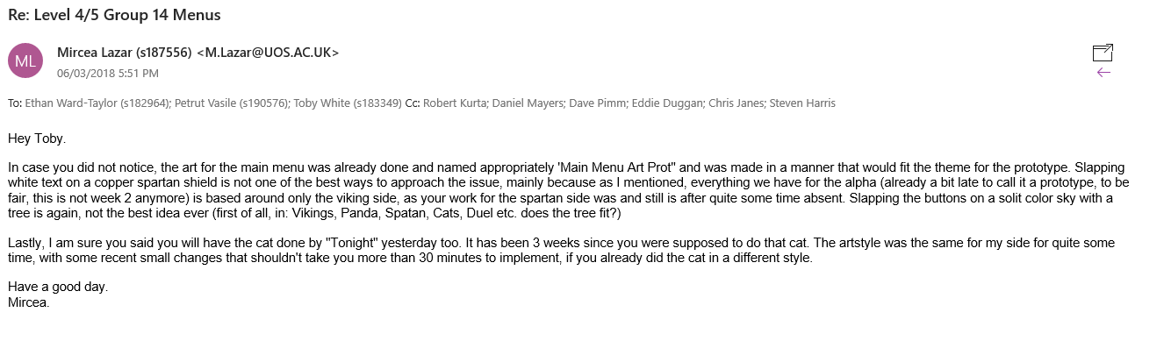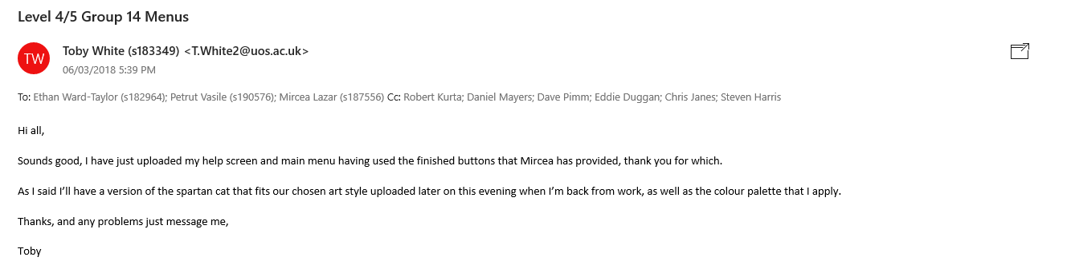Emails:

